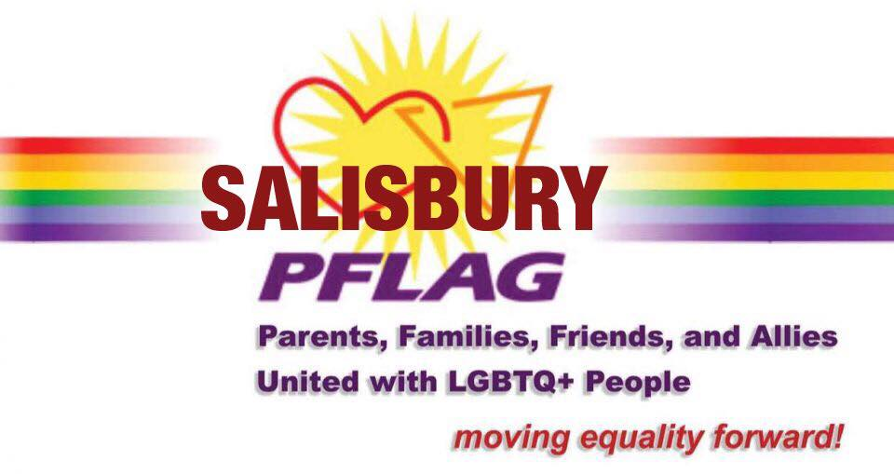
Media Contact: Mark DeLancey
Phone: 603-662-7591
SalisburyPFLAG@outlook.com

NEWS RELEASE
FOR IMMEDIATE RELEASE: 7/2/19
COMVERSATIONS FOR A CAUSE:
SALISBURY PFLAG AND FREE STATE JUSTICE TO HOLD LGBTQ COMMUNITY FORUM
Salisbury PFLAG and FreeState Justice, Maryland’s LGBTQ advocacy organization, will hold an open conversation about issues facing the LGBTQ community in the State in order to gauge how to best serve all Marylanders. The vital information gathered at this event will help set Free State’s 2020 legislative policy agenda.
This event, which is open to the public, is scheduled for July 23rd from 6-8pm at the Unitarian Universalist Fellowship Salisbury, 2812 Old Ocean City Rd., Salisbury MD 21804. This is an outstanding opportunity for community members on the Eastern Shore to lend their voice, inform the agenda, and get involved in the shaping of public policy.

FreeState Justice is an LGBTQ+ civil rights advocacy organization that works statewide to improve the lives of lesbian, gay, bisexual, transgender, and queer (“LGBTQ”) Marylanders through legal services, policy advocacy, outreach, and education. In this way, they work towards a Maryland where people across the spectrum of sexuality and gender identities are free to live full, authentic lives, with safety and dignity, in every community throughout our state.
Despite recent, incremental judicial victories for the national LGBTQ community, the low-income LGBTQ population continues to struggle with legal challenges such harassment, complex family law issues, and anti-LGBTQ discrimination in employment, housing, foster care, healthcare and public accommodations. In addition to needing attorneys with specific knowledge of how the law affects LGBTQ citizens, LGBTQ clients need attorneys who will treat them with respect and understanding. FreeState’s mission is to combine direct legal services with education and outreach to ensure that the low-income LGBTQ community Maryland receives fair treatment in the law and society.
FreeState also works to improve the lives of all LGBTQ Marylanders through public policy initiatives. During the 2019 legislative session Free State Justice supported the following: Funding for the Ending Youth Homelessness Act Grant Program, SB0251/HB1183: Disrupt HIV Act, SB0196/HB0421: Modernizing State Issued Identification, SB0697/HB0519: Recognizing All Families and Ensuring the Well Being of Children, and SB0905/HB1005: Modernizing Name Change Procedures. More information about the legislative activities of Free State Justice at https://freestate-justice.org/what-we-do/policy/session-2019/
Salisbury PFLAG was founded in 2015 and meetings are open to the public and are held on the second Monday of the month from 6:30 to 8:00pm at the Unitarian Universalist Fellowship located on Old Ocean City Road in Salisbury.
PFLAG is the largest Lesbian, Gay, Bisexual, Transgender, and Questioning/Queer (LGBTQ) ally organization in the nation. PFLAG envisions a world where diversity is celebrated and all people are respected, valued, and affirmed inclusive of their sexual orientation, gender identity, and gender expression. By meeting people where they are and collaborating with others, PFLAG realizes its vision by providing support for families, allies, and people who are LGBTQ; providing education about the unique issues and challenges facing people who are LGBTQ; and providing advocacy in the community to change attitudes and create policies and laws that achieve full equality for people who are LGBTQ.
The Unitarian Universalist Fellowship, which is the location for this event, embraces diversity and offers spiritual nourishment to all members. The Fellowship seeks to affirm the worth of each individual while supporting compassionate justice in our society.
More information can be found on the Facebook event page at https://www.facebook.com/events/2263997053851688/ or by contacting Salisbury PFLAG at SalisburyPFLAG@outlook.com

